
Emirates Natural History Group
Al Ain Chapter
Newsletter 2010/ I

Dear Friends
After the quiet weeks of Christmas and New Year we proceed with organizing weekend hikes and trips. Watch out for the mails announcing the trips.
Previous weeks highlight has been the IEW, the annual meeting of all ENHG chapters. Please look below for report.
The upcoming photo-exhibition marks the next highlight of our frequent activities. It will take place on the second General Meeting in May. Please look down for more information.
The newsletter depends also on YOUR contributions! If you have any reports, sketches, stories, pictures, encounters, poems, etc. please submit to rolfried@yahoo.de

ENHG Al Ain Chapter Committee
Committee members:
Chair: Brien Holmes; Vice Chair Brigitte Howarth; Treasurer: Jodie Healy; Secretary: Walter Cramerstetter; Membership: Barb Reimer; Photography: Bob Reimer; Newsletter: Roland Ochmann; Library: Marybeth Gaudette; Flora: Jodie Healy, Brigitte Howarth; Fauna (Insects): Brigitte Howarth; Fauna (Birds): vacant; Environment: Jodie Healy; Ordinary Members: Jerry Buzzell, Bill Jones, Amer Abu Kuhail, Joseph Mansour, Jake Gilson, Alison Lawrence

Visit the webpage at www.enhg.org or contact us at enhg@yahoogroups.com (all Al Ain chapter members).

Committee meetings are held on the first Tuesday of each month in the work room at Al Ain English Speaking School. Everyone is welcome to participate! We are always looking for people to join our discussions and help deliver events. The next Committee meeting will be Tuesday 06 April at 7:30 pm.

Upcoming Events

2010 Tuesday Apr. 13, General Meeting, InterContinental Al Ain Resort hotel, 7:30 pm

Tuesday Apr. 27, General Meeting, InterContinental Al Ain Resort hotel, 7:30 pm

Tuesday May 04, Committee Meeting, AAESS, 7:30 pm

Tuesday May 11, General Meeting, InterContinental Al Ain Resort hotel, 7:30 pm

Tuesday May 25, Photo Exhibition, InterContinental Al Ain Resort hotel, 7:30 pm

Annual Photography Exhibition
The Emirates Natural History Group, Al Ain Chapter is pleased to announce one of our most popular events on the season's calendar, the annual photography exhibition. The exhibition will be held at the Tuesday, May 25th meeting with entries due on Tuesday, May 11th. You must be a member to exhibit; all are welcome to view the exhibition.
This year the committee has thought long and hard about the direction of the photography competition. We have decided to try to better align it with our goal of "Observe, Record, Report" and de-emphasize the competition aspect by changing the competition to a juried exhibition. While we will still have judges for our exhibition, the duties of the judges will change. Rather than picking first, second and third place winners, the judges will be asked to select "photographs of note". We expect that some of the "photographs of note" will be for photographic excellence, but some may be for capturing unique images that are difficult to reproduce or other reasons the judges agree on. There will be no cash prizes this year, but but we will be producing certificates for "photographs of note" similar to what has been done for prize winners the past few years.
There will be fewer categories this year, with fewer entries per photographer (four instead of eight) and a restriction of two entries per category. In the past it has been difficult for some entrants to fit their pictures in a particular category leading to quite a bit of overlap in subjects for several of the categories. Hopefully, with fewer categories, this will be less of an issue.
Full details of the exhibition are available on the ENHG web site at http://www.enhg.org/alain/photo2010.htm. Please note that we would like you to email smaller digital versions of your entries to photocontest@ enhg.org for use in the PowerPoint presentation on the day of the exhibit.
Here are some suggestions, if you would like to improve your photography. First, take pictures! There are a number of good web sites that will help with many aspects of your photography and also provide critiques of your images if you would like that help. For landscapes, my favorite site is
http://www.beautiful-landscape.com. Alain Briot's essays are thoughtful and thought provoking and can help in many aspects of the photographic process. For natural history photographs, Arthur Morris' forum http://www.birdphotographers.net provides excellent critiques and educational tips.
When printing your photos, two complaints I hear (and sometimes make) are, "the photograph had different colours on the screen than it did on the print" and "the print is darker than it looked on my screen."
The first problem is caused by having a monitor that isn't calibrated. If you are finding difficulty with this, I have hardware and software that will calibrate your monitor and am willing to help out at mutually agreeable times.
The second problem is caused by the fact that the monitor is lit from the rear while the paper photograph is lit by reflected light and therefore will often appear darker. This needs to be accounted for when you adjust the photograph for printing.
Which brings up the point about post-processing your digital images. The term "photoshopping" has become part of the vernacular now, but you don't need to have Adobe Photoshop in order to optimize your images. Most camera manufacturers provide software with their cameras which is quite capable. Free software such as FastStone Image Viewer and GIMP can be quite useful. If you want many of the features of Photoshop, without the large price tag, you might want to consider purchasing Adobe Photoshop Elements.
Now is the time to start going through your images from the past year and select your best. As you take more pictures over the next few weeks, decide whether you prefer some of your more recent images to your previously selected ones. As it gets closer to the entry deadline, you will have a selection of work to pick your favorite four of to print and exhibit. We're looking forward to receiving those entries on May 11th and seeing you at the exhibition on May 25th.
Warm regards, Bob Reimer

Walking and Hiking Trails in Al Ain

For several months, we have been working with staff in the Town Planning Department to develop Walking Trails for residents, tourists and visitors in Al Ain city and Hiking Trails on Jebel Hafeet. The trails on Jebel Hafeet would offer different levels of difficulty and would include signs with explanations of the geology, plants and animals. We will keep members informed of further progress.

What Happened on Recent Hikes, Walks

Each weekend we try to offer one or two field trips to some of the destinations within a short driving distance of Al Ain. Our field trip leaders are all volunteers and each tries to make each field trip as interesting and informative as possible. We are always looking for volunteers to lead trips; please contact a Committee member if you would like to lead trips.
We ask members to dress appropriately and wear proper footwear. Please remember to bring plenty of water and a snack. It is important to let the trip leader know if you have a medical condition which the field trip leader should take into account when selecting routes etc. Our field trip leaders carry a satellite phone on most trips; members should carry a small first aid kit.

Friday 18 Dec Al Ain old souq
Saturday 19 Dec Wadi check after the rainfalls
Thursday 24 Dec: Christmas Eve near Jebel Quattara
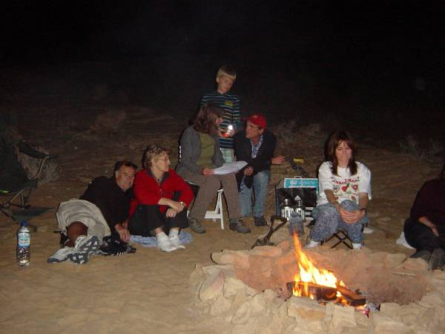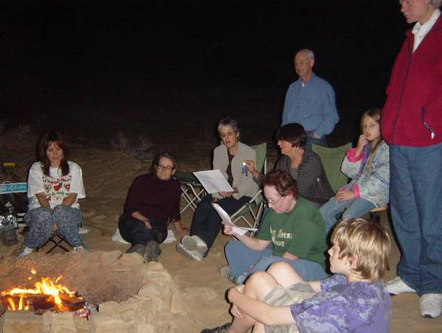
Singing of Christmas carols after BBQ
Friday 01 Jan Jebel Hafeet tombs
There are over 500 known grave sites around the Jebel, dating back around 5,000 years. Although many have been destroyed (maybe not recognized for what they are?), the Department of Antiquities have restored some along the base of Jebel Hafit. The tombs are up to 4 metres high, and the entrances face south. You will be able to explore and enter several of these restored tombs, and climb up to see other possible graves along the lower mountain slopes.
Here are updated pictures of Hafeet tombs and Mezyed fort by Amer
http://someone1986. blogspot. com/2010/ 01/hafeet- tombs-and- mezyed-fort. html
Saturday 02 Jan Wadi Aboul
Friday 15 Jan Follow-up meeting to Jazira
varied activities to suit those that liked to observe fauna and flora but also for those who liked to enjoy the peace and quiet of this lovely mountain oasis.
On arrival some wandered through the oasis, or got involved in identifying plants or insects. Opportunities for walking up the wadi, returning via some abandoned houses and appreciating the way people would have been living up until just a decade ago or so. Before dark we have set up the chapter's mercury vapour light near the gorge in order to attract flying insects. As Bob reported, up to now the midges he found riding on dragonfly wings have all been females and those that are helping describe this 'new to science' species have expressed an interest in also finding a male to add to the holo type female Bob has provided. Therefore, as the last rays of sun disappeared we have set up our own 'sun' or light and attracted some flying visitors for us to study for about an hour.
Friday 22 Jan Subeitah Oasis- exploring plants and animals
Subaitha was one of Marijke Jongbloed's favourite destinations as the plant diversity is phenomenal, especially along the falaj that exits the oasis and leads to the pool we enjoy a dip in. One of our most memorable field trips to Subaitha was when Marijcke lead a trip for us, and we do have footage of this visit amongst our archives. Subaitha is a mountain oasis with a deep gorge. The wadi leads also to the pool, just as the falaj does. Therefore, we were able to split up the group and offered those that prefered to walk in the gorge the opportunity to do so, whilst others walked to the pool along the falaj which is at a lofty height. Some of us meandered rather more slowly and tried to identify fauna and flora along the way.
Saturday 23 morning trip to Wadi Nahyan for a flora and fauna walk
afternoon hike to “infinity pools’
Friday 05 Feb: Fossil Valley
As a result of the December rains, the annuals in Fossil Valley begun to make their appearance. The trip out to Fossil Valley was to observe, identify and record this year's annuals (as well as looking at the progress of the perennials). As Fossil Valley is a large area we concentrated our efforts in a couple of different locations within the valley.
Friday 12 Feb: Morning hike to hanging gardens to observe the effect of recent rainfalls
afternoon trip to Jazeera oasis for the monthly record of plants, species, etc.
Thursday 25 to Saturday 27: IEW
Friday 19 Mar Musah Oasis
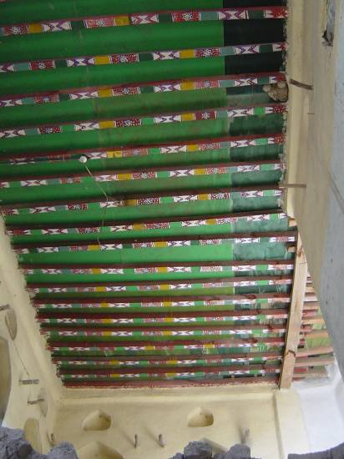
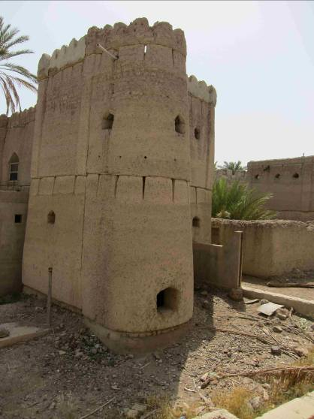
Friday 26 to Saturday 27 Bahla/ Hamra weekend
A weekend trip, started with exploration of old Bahla village around the Bahla Fort and short look to the souq. Unfortunately the pottery was closed (Friday noon).

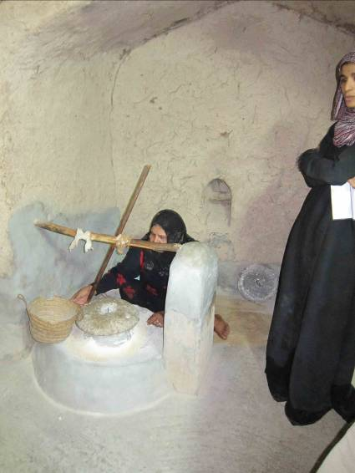
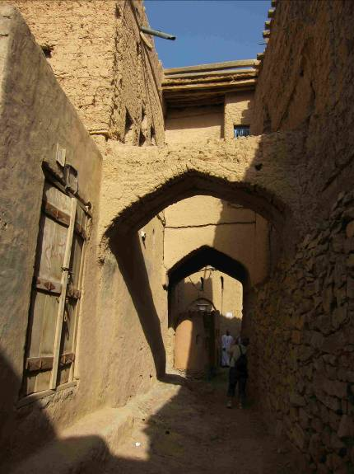
After a short noon brake we drove to Hamra old village, strolling around, experiencing the traditional works in a living museum. After relaxing walk through the oasis we moved to Yarya oasis for the star gazing experience.

Saturday morning we took again a stroll through Yarya oasis and the falaj system, then we went to Misfat scenic village (report by Cheryl see below)

Friday 26 Mar Dayhike with Bill

RECENT MEETINGS
Dragonflies
Tuesday 12.Jan 2010
Bob Reimer spends a lot of time recording insects in the field using his camera. A few years back when going over his photographs of dragonflies he noticed 'something' on the wings of some dragonflies. On closer inspection this turned out to be a small midge! Bob has since then been recording this occurrence and had shared some exciting news with us. Many theories exist as to why some insects 'hitch a ride' with others, but Bob will gave us his own view based on further research. Bob's interest in damselflies and dragonflies has also resulted in joint authorship with Gary Feulner and Dick Hornby (Tribulus, Vol. 17, p. 37-62).

Translocation of corals in Jebel Ali and Palm Jebel Ali area (Dubai)
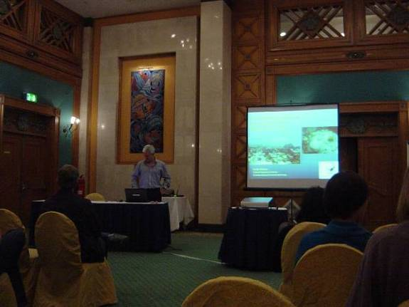
Tuesday 09.Feb 2010
Keith Wilson is a marine biologist. Before he moved to UAE, he was Senior Fisheries Officer with the Agriculture, Fisheries and Conservation Department, Hong Kong SAR, China for 13 years. He came to Dubai to work for Nakheel about two years ago and is now working with the Emirates Marine Environmental Group where he is director of their Marine Programme.
He spoke to us about EMEG's coral translocation project. and gave an impression of how corals have been translocated caused by construction and dredging activities in the area of Jebel Ali, Dubai. Methods, difficulties, statistics about mortality and species of corals have been presented.

Fish studies in the Al Ain fish souq
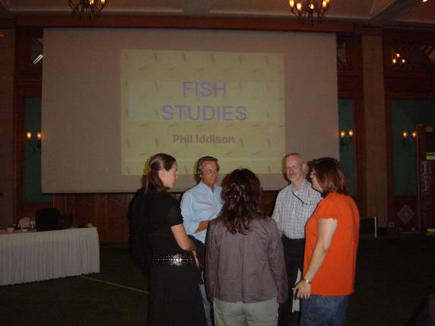
Tuesday 23.Feb.2010
Phil Iddison, one of our lifetime members, talked about his discoveries in the Al Ain fish market, praised the benefits of the locations (the fish cannot escape and pictures can be taken without any hurry) and transferred a lot of information about diversity, source and specifications of what can be found in the market.
Members had the opportunity to follow his lecture on the following Friday at the IEW’s morning walk to Al Ain souq.

Historical importance of pearling in the Gulf
Tuesday 09 March.2010
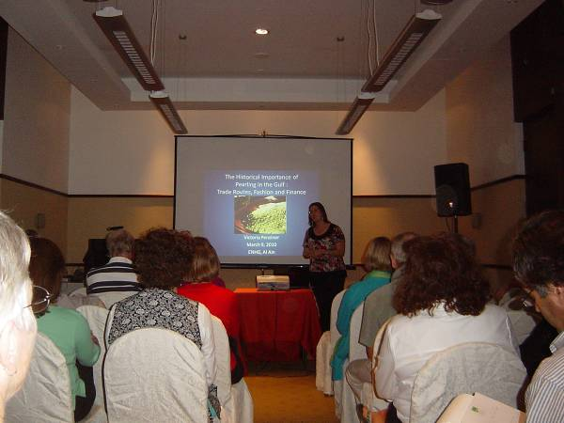
Victoria Penziner, a Fulbright stipendiate of Florida State University and one of our members, researched in previous weeks about pearl fishing and trading. She talked in a vivid lecture about trade routes, fashion and finance of the pearling in the Gulf region.
It comes out that this business of pearl fishing and trading was extremely volatile and one of the first victims of globalization because pearls are a real luxury good and depends on wealth and fashion.

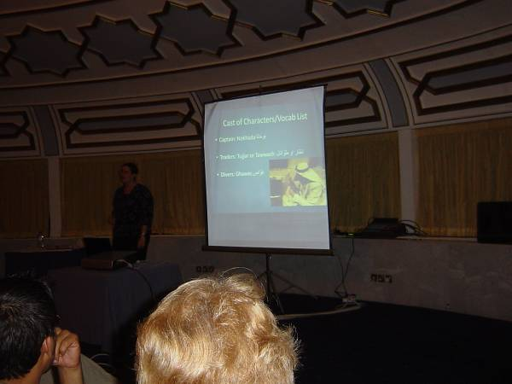
Facts and figures of pearling in the Gulf
Tuesday 23 March.2010
In the second part of Victoria Penziner’s lecture we heard about the problems of “doing the pearl diving”: How to find the pearl banks, how to recognize the right mussels, fight with wind, weather, illness, injuries, living on the boats and all the logistic beyond.

IEW Special

The IEW took place form 25 to 27 February 2010, this years host has been the Al Ain chapter.
Pictures and reports of single events
Thursday evening: Light trapping (16 participants)
Moonwalks
Afrathe to Big structure (4 participants)
The hike started near Afrathe with an ‘up and over’ and then lead into an expansive plain, ended up in what we call Big Structures (due to the remaining of big structures there). These are the remnants of a settlement and include terracing and a falaj system.
Khutwah to Village One (17 participants)
A pleasant walk to an abandoned village upstream from the Khutwah Oasis. We followed the falaj to Sultan's Oasis and hiked up and over Bob's Ridge to the village. An alternate route was taken back to the Khutwah Oasis, going around the ridge and following a donkey trail beside the wadi.

Friday Morning
  - Al Ain birding fieldtrip with Dave (11 participants)
There are two locations in Al Ain: At Green Mubazarrah we looked for resident mountain birds, such as hooded and Hume's wheatears, buntings, Barbary falcon, babblers, sand partridge and wintering and migrating birds such as plain-leaf, Menetrie's, desert Asian and other warblers, red-tailed and desert wheatear, blue rock thrush, shrikes and the occasional odd bird.
We started in the parks grassy areas and then headed to the acacia trees in Wadi Nayhan. After Green Mubazarrah, both are close, so either: the Water Treatment plant lake, in time to saw flocks of chestnut bellied sand grouse making their daily trip from as much as 30 kilometers away for their daily drink of water. Also at the lake have been numerous waterfowl, waders, swallow and martins, and the occasional raptor.
The visit to the manmade wetlands of Zakher Lake (aka Khasis Lake) where many types of herons and other large waterfowl could be seen.
  - Al Ain souk with Phil and Amer (17 participants)
A walk through the central market area in Al Ain. It has been interesting to see the changes since Phil’s last visit in 2006, for instance the range herbs and vegetables for sale, were there still foraged items, what range of fish species were on display, have the range of traditional and craft items diminished?
  - Al Dhaher oasis (36 participants)
The oasis at A'Dahir, located above a deep wadi bed, is a well-kept collection of small farms with fodder crops, a variety of citrus and other fruit trees in addition to the date palms. A'Dahir has not seen the transformation to market gardening that has been introduced elsewhere (i.e. Khutwah) and many of the villas are still occupied by Omani residents and laborers. The tour included the falaj systems and the oasis. The area is rich in cultivated and native plants.
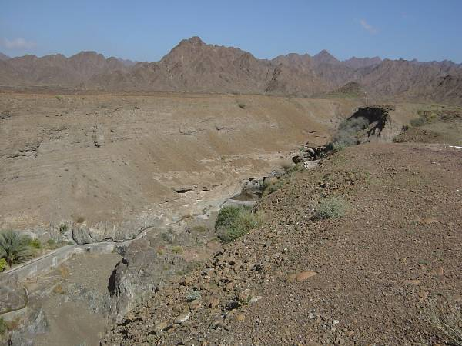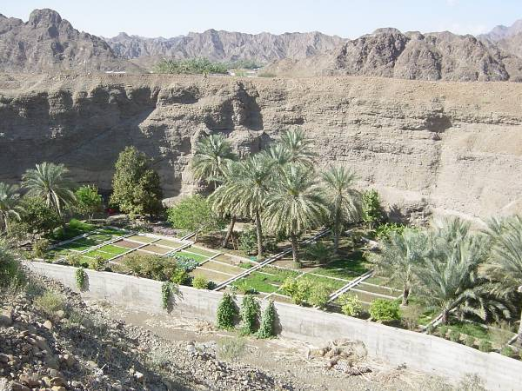
A Sighting at A’Dahir Oasis
On Friday morning Feb. 26th, Brien Holmes led an IEW walk into the A’Dahir wadi in the Hajar Mts behind Mahada. Principal attractions were the traditional plantation, a rich assortment of native plants responding to recent rains, and a working underground falaj system. During the lunch break Martina climbed down into one of falaj shafts and photographed the bat below. –FOCUS Ed.
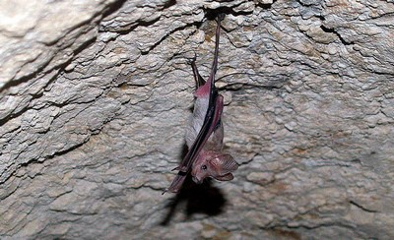
Photo: Martina Beck

My main question about this bat was: Why was it alone at the entrance of the falaj? Was it sick? I asked Drew Gardner, and he answered my question and returned the following identification: The bat is a Muscat mouse-tailed bat, Rhinopoma muscatellum (and clearly a male!). You can tell by the thin long tail, and also because it does not have a nose leaf. This species often roosts alone, and was almost certainly not sick.
However, there were almost certainly other bats in the falaj, also hanging apart from the others. That falaj usually has between 50 and 200 mouse-tailed bats scattered along its interior.
Martina Beck

  - AlAin oasis with Phil and Amer (36 participants))
A stroll through the Al Ain Oasis, with itse water management, a range of construction styles and materials, details of date palm cultivation, other crops, flora and possibly some wildlife to be observed.
  - Work shop insect orders in the UAE (7 participants)
  - Field trip Wadi plants with Jodie (8 participants)
We went to Wadi Khudrah to look at the different types of plants that grow in or near the wadi and looked at some of the features of their general habitat that influence their growth. We recorded the different species that occur and made observations about them including their association with other flora and fauna
  - Work shop flint knapping with Jeff (14 participants)
Jeff gave a short presentation on flint knapping, including materials suitable for knapping, the mechanics of rock fracturing, and flint knapping tools. It has been followed by a 30-40 minute movie demonstration of techniques by a professional knapper, an opportunity to view points knapped by Jeff using different materials, and some took the chance to try their hands at knapping some local chert.
  - Work shop fossils with Val (20 participants)
The fossil workshop showed participants the range of fossils to be found in the UAE, with particular reference to Fossil Valley and helped to make them familiar with them. The basic characteristics and distinguishing features of the various groups of fossils have been pointed out with the help of specimens, photos and worksheets.
Afternoon
  - Al Ain sand dune walk (9 participants)
  - Wadi Nahyan plants, insects, birds (28 participants)
  - Mezyad fort and Jebel Hafeet tombs with Amer (34 participants)
The Fort at Mezyad is the last of the facilities used by the Trucial Oman Scouts that has not been either destroyed or modified beyond recognition. Restoration work on the fort was halted several years ago and its future is still under discussion.
The Jebel Hafit tombs date from the 3rd millennium with several having been reconstructed. Some of the original tombs can still be seen.
  - Al Dhaher to Ihlal hike (25 participants)
For this picturesque trip in the Hajar Mountains, participants followed remaining segments of a trail that follows the main channel of Wadi A'Dahir into the mountains before crossing 'Viper Ridge' and descending into Al I'lal. There were a few ascents and descents in to and out of the wadi bed; trail markers, some archaeology and wall constructions en route.
A Sighting on A’Dahir to Al I’lal Hike
On the hike Brien Holmes and Jodie Healey led out of A’Dahir Friday afternoon, Feb. 26, there was high drama if you happened to be lucky enough to see it:
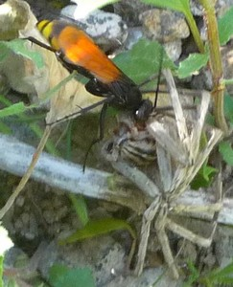
Photo: May Yoke Taylor
A spider-hunting wasp, possibly Cyphononyx bretonii, the Spider Witch, is dragging a wolf spider through the bushes. It has paralyzed the spider, and is taking it to a secure location, where it will lay its eggs in it. Once hatched, her larvae will proceed to eat the spider alive!
Keith Taylor

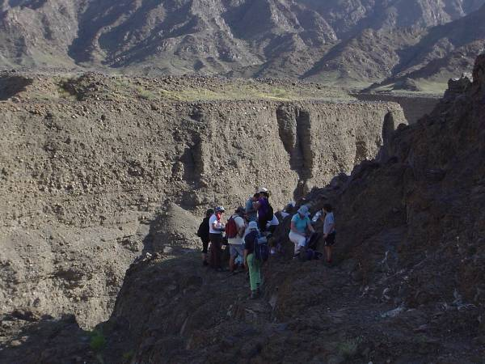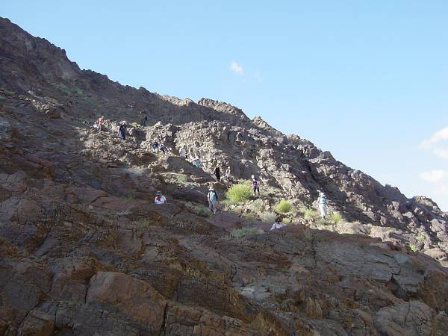
Short break before the descent into “Grand Canyon”

  - Fossil valley geology (16 participants)
  - Khail to Sharm drive (15 participants)

Evening (132 adults, 1 child participating)
IEW 2010 Buffet Dinner and Awards
A varied programme of interesting and informative field trips and workshops, spread out across Al Ain and the Buraimi/Mahada area of Oman Feb 25 - 27, was complemented by a well-attended buffet dinner on the Friday evening. The one unforeseeable hitch in the proceedings came when a temporary closure of the Hili border due to a chemical spill delayed the return of quite a few participants from trips on the Oman side, including the host of the evening, ENHG-Al Ain Vice Chair – Brigitte Howarth. Dinner was delayed accordingly, and the formal proceedings didn’t get underway until about 9:15, as Buraimi returnees – some straight from the field – straggled in and helped themselves to the still plentiful buffet.
ENHG Chairman Drew Gardner began the evening programme by reading a commemoration of the life of Sheikh Mubarak Al Nahayan, who had passed away two days before, occasioning an official three days of mourning in the UAE. These remarks, written by former ENHG Chairman Peter Hellyer, reminded us that Sheikh Mubarak was the first Minister of the Interior of the UAE, and in many ways was one of the founders of the UAE as we know it today. And of course, he was the father of our Patron, Sheikh Nahayan bin Mubarak, who named one of the ENHG’s two Natural History awards after him.
Drew then proceeded to the announcement of the Sheikh Mubarak Natural History Award, which is “given to acknowledge the contributions made by an individual, primarily through original research and publication, to the scientific study of the archaeology, history and natural history of the UAE.”
The 2009 Sheikh Mubarak Award was awarded to Dr. Christian Velde, the chief archaeologist at the National Museum of Ras al-Khaimah, for successfully re-organizing that museum and for overseeing, contributing to and publishing on an important programme of excavation, restoration and conservation, leading to a number of important discoveries, including the largest defensive structure known in Arabia - the long wall (10+ km) that formerly protected the town of RAK/Julfar.
With his many years of service to the furtherance of archaeological research in the UAE, and his services to the DNHG and ENHG as speaker, mentor, and guide, Dr. Christian Velde is an exemplary recipient of the Sheikh Mubarak Natural History Award. He was unable to attend the IEW dinner because of prior commitments, but he will be invited to an official award presentation later this year, after which a full report on his remarkable contributions to archaeology in the UAE will be published in Focus (the Abu Dhabi Newsletter).
Next came the announcement of the Bish Brown Award, named after the ENHG’s founder, which is “given to a person who has made a significant contribution to promoting wider interest in the objectives of the UAE’s three natural history groups, through means such as educational activities, raising public consciousness in the media, playing a leading role in NHG activities etc.”
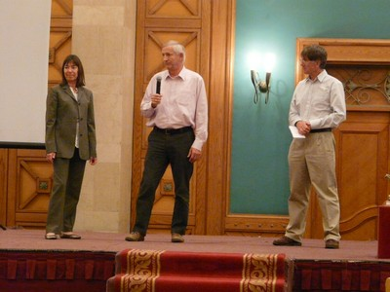
The 2009 Bish Brown Award was given to ENHG members Hanne and Jens Eriksen, who have been promoting SE Arabian Natural History and especially birds through their photography and publications for the last 20 years or so. Their bird photography is world renowned, having won numerous international competitions. Their books include a Birdwatching Guide to Oman (2001, 2008), Common Birds in Oman (2005) and The Birds of Al Jebel Al Akhdar (2007) among others. They have published a bird calendar each year for at least the last 10 years. Their bird images have appeared on stamps, bank notes and a huge arrange of publications.
Hanne & Jens Eriksen accepting the 2009 Bish Brown Award from ENHG Chairman Drew Gardner
Photo: May Yoke Taylor

Hanne and Jens have given slide shows to all three chapters of the ENHG (since long before making the move from Muscat to Abu Dhabi) and have run the ENHG book table for the last 4 years. Although much of their output has been Oman-based, they have always maintained strong links with the UAE including working with Marijcke Jongbloed, the Arabian Leopard Trust, the Sharjah Captive Breeding Centre etc. And while accepting the award, Jens said the first talk they ever gave in the UAE was in Al Ain – in the same hotel –exactly ten years before!
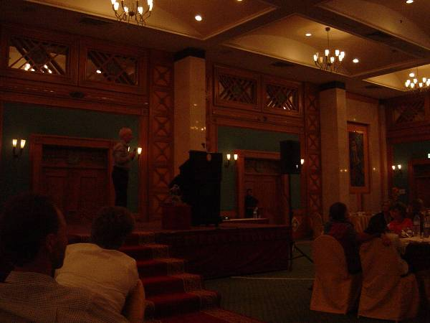
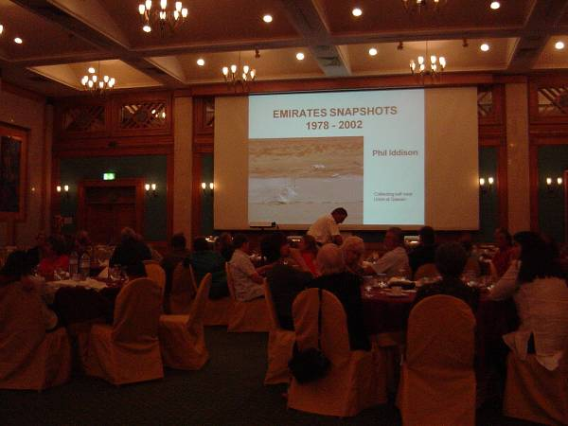
The featured speaker of the evening after the awards presentations was Phil Iddison, the 2002 Sheikh Mubarak Award winner (for his contributions to the study of food in the UAE). Phil entertained us with a cornucopia of photos and anecdotes gleaned from his many years as a member of the ENHG-Al Ain chapter. He led us on a tour of the early development of the cities of Al Ain and Dubai, filled us in on the important stages of date cultivation and uncovered fascinating facts about traditional doors and keys from the region, among many other things.
Running through his talk was a spirit of all-inclusive enquiry and eagerness to share, mirroring what the three NHGs that come together every year during the InterEmirates Weekend are all about.
After dinner, some stayed to renew old acquaintances or make new ones, others wandered out to the lawn to join the ENHG’s Andrew Bean for a spot of astronomy, using the club’s Celestron telescope and Sky Scout tool for identifying and locating astronomical objects. Most headed “home” to rest up for another day of events, braving blustery weather that only whetted appetites for more.
by Keith Taylor / Drew Gardner

Saturday morning
  - Hanging gardens hike with Bill (29 participants)
We hiked to the base of the plateau on Jebal Qatar to an area called the Hanging Gardens. There is a permanent water source which supports a variety of plant and bird species. We recorded the different species that occur on the approach to and in the Gardens
  - Medicinal plants in the field (12 participants)
  - Wadi Madbah drive
22 participants headed to Wadi Madbah and extended their visit by more an additional half hour by popular demand.
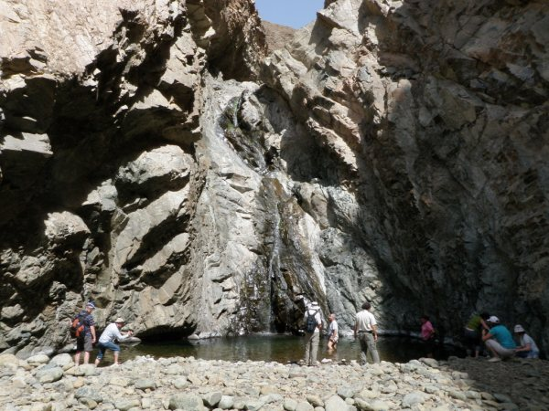 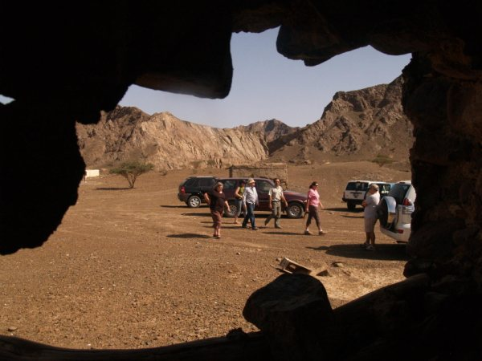
pictures taken by Roberta Zelari
  - Workshop: medicinal plants (12 participants)
  - Workshop: keys to identify reptiles (10 participants)
  - Workshop: insect collection, beetle identifying-(5 participants)
A Peek at the ENHG Insect Collection
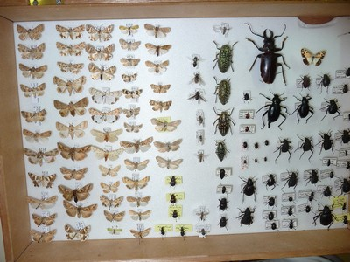
On Sat. Feb. 27, ENHG-Al Ain Vice Chair Dr. Brigitte Howarth treated a small group of us to a viewing of selected specimens from the ENHG Insect Collection, a joint collection housing specimens collected by ENHG founder Bish Brown and others such as Mike Gillett, and currently under Brigitte’s curatorship. These specimens are carefully mounted and labelled in hinged wooden display boxes, but on Brigitte’s wish list for this important ‘amateur’ collection is a large state-of-the-art metal cabinet to more effectively preserve it for as long as possible.

Moths and beetles from the ENHG Insect Collection

Brigitte explained that after the collection was brought out of long-term storage she was convinced that many species found in the collection had not been reported in the literature before and together with ENHG-Al Ain beetle specialist Dr. Michael Gillett found that it contained three rare species from the jewel beetle family (Buprestidae), which had never been found in the UAE before Bish recorded them: Julodis candida, Capnodis excisa, and Pseudocastalia arabica. See April 2009 Focus (pp 6-7) for Dr. Gillet’s comments on fairly recent sightings in the UAE of the first two species. The fourteen specimens of the last species, P. Arabica, shown below, testify to how numerous they were when Bish collected them near Sweihan in the early ‘80s.
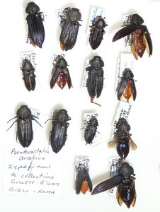
For more information on the significance of some of the findings represented in the ENHG collection, see the following article by Brigitte Howarth and Michael Gillett:
Increasing knowledge of the entomological fauna of the United Arab Emirates and the role of private collections
Clicking on the above link should bring up a download page for this article from Pensoft Online: a site hosting two excellent natural-history-related open-access journals: ZooKeys, ‘launched to accelerate biodiversity research’, and BioRisk – Biodiversity and Ecosystem Risk Assessment (To register for these journals FOC, use links in ‘Websites of General Interest’ panel, p 7).
In her workshop, Brigitte also showed us how to recognise jewel beetles if we see them. They usually have elongated, somewhat robust bodies (with a slight ‘waist’), a metallic shine, and short saw-toothed antennae; some have eye-catching, jewel-like patterns.
Pseudocastalia arabica collected by Bish Brown
Keith Taylor Photographs by May Yoke Taylor

  - Workshop and field trip: dragonflies (4 participants)
  - Jimi oasis walk with Amer (9 participants)
In the heart of Al Ain, the Jimi Oasis is one of the oases that formed the Buraimi Oasis complex mentioned in travelers' accounts of the region. This walk, originally designed by Phil Iddison, took visitors down into the heart of the oasis to enjoy date gardens, falaj systems, mud walls and more.

Afternoon
  - Afrathe combined session (8 participants)
A perfect ending to a perfect weekend to observe and record plants, insects, reptiles and some archaeology in the settlement of Afrathe, located near Musah.

We say Thank you so much! to everybody who made this event a remarkable one, either in front or behind the curtain, hoping that all participants and members have had fun and experience, making new friends and we are looking forward to the next IEW 2011.

Reprise: The 1st Middle-Eastern Biodiversity Conference in Aqaba, Jordan, 2008
We are proud to announce that the lecture of Brigitte Howarth and Mike Gillett about “Increasing knowledge of the entomological fauna of the United Arab Emirates and the role of private collectors” has been published on 28 December 2008 and can be retrieved on www.pensoftonline.net/zookeys

Skinks and their shiny skin

If you have ever been out at dawn or dusk you may have seen a small creature waddling across the soft side of the sand dune, once you have realised what you are seeing is a sandfish you may have been struck by just how slick and shiny they look, almost as if they are wet. However they are not slimy, these creatures are highly polished and so researchers in Germany have been studying just how slick their scales are, and why.

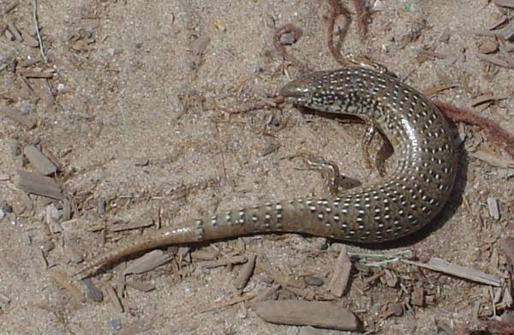
The eastern sand skink and the common sand skink are perfectly adapted to life in the soft sands of the leeward side of the dunes. Their short legs and shovel-like snouts allow them to walk quickly across the sand, these features also allow them to dive under the sand the moment they feel threatened.

The skin is very shiny, and although it looks very smooth to the naked eye at a microscopic level it is covered in ridges and bumps that actually help the sand to flow over it. This is similar to surface used in self cleaning glass, which was itself inspired by another natural object, the sacred Lily.

In 2000 Ingo Rechenberg & Abdullah Regabi El Khyari started experimenting on Scincis scincus in Morocco. Using a glass funnel, similar to an hour glass they poured sand on both dead and sedated specimens and measured the angle at which the sand would start to flow, the average angle was about 22 degrees.

Definition and measuring of the dynamic friction coefficient μ
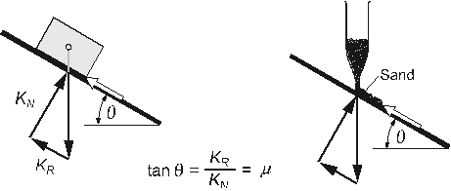

Fig 1. From http://www.bionik.tu-berlin.de/institut/xs2skink.html

In order to make comparisons they used the same method to measure the resistance of teflon steel, glass and nylon. These proved to be much less smooth than the sand fish’s skin. When they repeated the experiment yet again they found that with a live unharmed skink the sand would flow at an angle 19 degrees.

In 2007 Werner Baumgarnter and others at the University of Aachen’s Bionics Department published a paper on the properties of skink skin, with relation to its structure and composition.

Using shed skins of captive skinks they discovered that it wasn’t the structure of the scales that provided the low friction but the material it was made of, the team were able to successfully reconstruct the material in the lab, and despite its different structure, it had similar properties.

The material reduces attraction of the sand to the scales right down to the molecular level.

The skinks used in the experiments were not the exact same species as the ones in the UAE, but they all have these adaptations in common, although they may vary slightly in their friction, as they inhabit slightly different habitats.

By studying animals and plants, we can often find ingenious engineering solutions to problems and there are many applications that lower friction in sand could have, such as for dune surfing boards, shovels, and on a more general level it could be used for scratch resistant surfaces or paint.

By Heather Mikhail

Further Reading on Bionics

http://www.bionik.tu-berlin.de/institut/xs2skink.html

The Sandfish's Skin: Morphology, Chemistry and Reconstruction- Werner Baumgartner, Friederike Saxe, Agnes Weth, David Hajas, Darwin Sigumonrong, Jens Emmerlich, Martin Singheiser , Wolfgang Boehme, Jochen M. Schneider.

Reibung und Verschleiß am Sandfisch der Sahara - Ingo Rechenberg und Abdullah Regabi El Khyari

The Gecko’s Foot - Peter Forbes

The Enchantment of Misfat
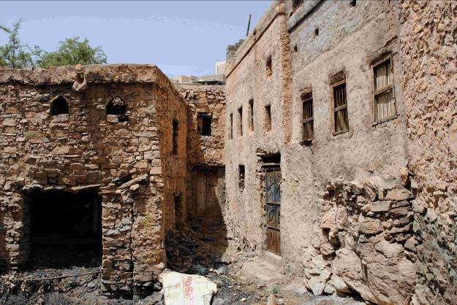
The ENHG never ceases to surprise me with the gems that await any of us who make the effort to get out and explore nature. Oman has such diversity to offer and it seems that much of the history of the area can be found in the rugged mountainous country as opposed to the dune environment of the UAE. Exploring the dilapidated community of Misfat is like walking back in time. Some mud brick structures seem to be three stories high as they are built on huge natural boulder outcroppings that form the downward slope of the hillside. With narrow walkways and stone laden walls surrounding me as I walk through the village, I spy small windows of varied design that add a unique bit of character. One walks among the passageways over the polished black rock worn down from eternal use that seems to be a natural fit of the oasis.
The aroma of curry floats throughout the ruins that still houses occupants. Walking down the terracing, one enjoys the deep tones of singing, assumedly the Quran. Moving through banana, papaya, and barley plots is so serene. The birds populate the foliage and occupy the air with their song.
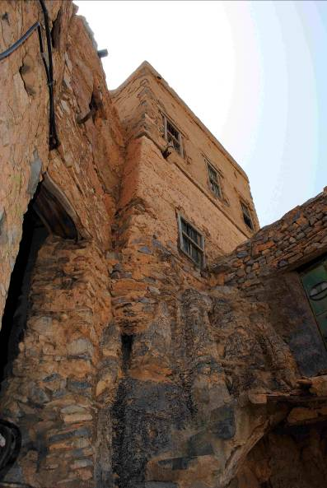
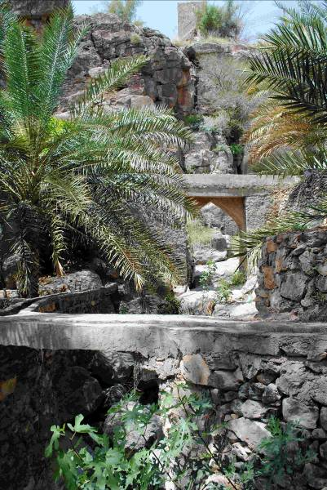
The community itself is built on terracing, which is usually reserved for farming purposes. What is so uniquely beautiful is the productive foliage growing on small terraced plots winding down to the bottom of the narrow wadi. On the opposite side of the canyon is the continuation of farming, falaj systems, and terracing with small structures spackled amongst the lush plants. Around each corner I find a different crop or even a donkey standing alone in a cave containment. Around one corner I have the pleasant surprise to come upon grape vines growing on the top of a wood arbor, which overlooks the canyon. Each terracing has smaller sections compared to what I’ve experienced in other oases, and I am surrounded by corners to explore around and enjoy the next surprising sight.
Standing with elegance above the old and current village is the watch tower or a fort. Tall and strong in the distance, I can still see that the rock walls are fitted together for strength and protection.
I am so moved by the oasis and the people working it. I always get such a sense of peace when I explore the oases around here and immensely enjoy the interaction with the workers I find living there as they add to the ambience of the place. Unlike in the UAE, here there are families of the workers around. At Misfat, children are playing in a nearly drained reservoir that became a natural swimming pool for them. As the afternoon wore on, others return home from school in their uniforms, awaiting greetings from mothers and an afternoon meal.
Misfat is a memorable place for me that I hope to return to one day. There are always moments in our lives that move us. This is a small one that is logged into my mind as a beautiful memory of smells, sounds and sights all collimating to produce an enchanting memorable moment in time. Cheryl Dance

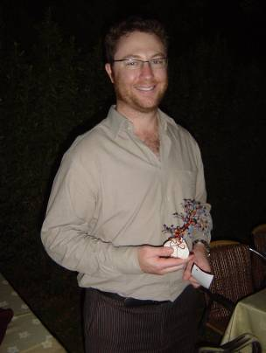
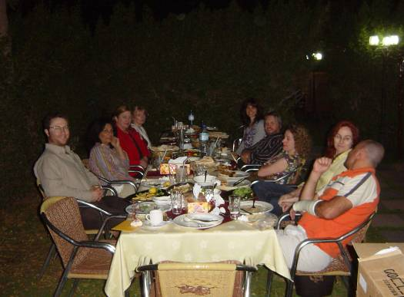
After 2 years in the UAE, Simon Wall, our ENHG-committee member and treasurer for over a year, is heading back to New Zealand. He had done all the monetary stuff and keeping the records together. We all wish him good luck for his future projects and goals. We had a nice farewell dinner in Bait al Shami garden restaurant on Tuesday 16 March.

Dates for your diary | Links
April 2010  13 General meeting (InterContinental)  20 Workshop (AAESS)  27 General meeting (Intercontinental)  May 2010  04 Committee meeting (AAESS)  11 General meeting (InterContinental)  18 Workshop  27 General meeting with Annual Photo Exhibition | Dragonflies!!!!  IUCN Odonata Specialist Group  Red-veined darter: http://www.thenational.ae/apps/pbcs.dll/article?AID=/20091129/NATIONAL/711289837  Wildlife Middle East News:  www.wmenews.com>.  Desert oasis:  http://www.environmentalgraffiti.com/featured/desert-oasis/2257  Mike Gillett’s contribution to our website  http://www.enhg.org/alain/mike/contrib.htm >.  Phil Idissons contributions on our webpage:  http://www.enhg.org/alain/phil/contrib.htm

Frequent Reminders

Hikes

The weekend hikes and walks in Oman or in the UAE are a regular part of our activities offered to members. Please read these hike-related mails carefully in order to be well prepared for the hikes (equipment, shoes, severity, etc.) also to get the right time and place to meet.

Thuraya Satellite Phones

We have two Thuraya telephones. The numbers are 0088-216-4440-5955 for Phone One and 0088-216-5552-1121 for Phone Two.

We recommend that you add these numbers to your mobile phones and lists of important phone numbers.

One or both phones will be taken on each field trip and will be turned on for the duration of each trip.

Find your way and meeting places in Al Ain and around.
Our weekend field trips begin at regular meeting places. You can download a KMZ file from http://www.enhg.org/resources/links/res_links.htm. Download the KMZ file and save it on your computer. If you have Google Earth loaded on your computer, when you double click on the file, Google Earth will open and ‘zoom’ to the locations marked. There is some information regarding each location associated with the pins in the image; hover your mouse over the pin to see the text. If you do not have Google Earth, or if the KMZ file does not work on your computer, you can download the JPG file also listed at http://www.enhg.org/resources/links/res_links.htm. The chapter’s regular meeting places for forming convoys are shown as are the Al Ain English Speaking School, the InterContinental and the Hili border crossing point.

The ENHG Library

The Library is now situated in our room at the Al Ain Palace museum. Marybeth has been busy attaching labels to the bindings of items in our collection as well as posting details of items on the Internet. Our library database can be searched and visited under www.librarything.com/catalog/enhg

If you’re looking for a publication, videotape or periodical, please contact Marybeth mary.gaudette@gmail.com. We try to put an inventory list on our webpage so everybody can look for something they are interested in or something special they may be looking for. Any problems? – just ask Marybeth.

We have prepared a DVD-collection of more than 20 DVDs and CDs including all videos, CDs and many of the DVDs in our library. We are offering this set to members for Dh100. These are available to ENHG members only. You can subscribe at the general meetings for your collection.

Items for Re-Sale to Members

Every Tuesday meeting our members have the opportunity to purchase reference books which members will find useful in the field as well as copies of items from our library collection.

Also on sale: DVDs and CDs with copies of old videotapes and movies in our Library collection. The collection includes copies of old movies produced in the 1960s and 1970s, including a profile of Sh. Zayed. Selling price Dh100.

We are also offering window stickers for your vehicle(s). Dh10 each.

