ENHG
Emirates Natural History Group – Al Ain

and

INTERNATIONAL OASIS UNIVERSITY (I.O.U.)
Al Ain – Buraimi Oasis

UAE – Oman

President – Nick Saines Janitor – Nick Saines

Bursar – Nick Saines Dean of Women – Nick Saines
Chair of English – Michael Caine Dean of Men – Who Cares?
Chair of Music – Steve Lawrence and Edie Gorme

present

A GEOLOGY WORKSHOP

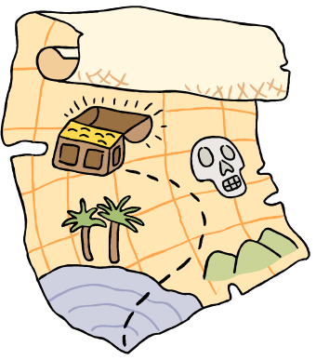
I – Physiography of the Al Ain Region

II – Introduction to Rocks

III – Stratigraphy

IV – Generalized Regional Stratigraphy

- Break -

V – Sand Dunes

VI – Beach Processes (to be discussed in the field on the beach on Friday March 30, 1984)

VII – Structural Geology (test your ability to visualize in three dimensions)

VIII – Interpreting Geologic History from a Geologic Section

I – Physiography of the Al Ain Region

Physiographic Units

Mountains
Alluvial fans
Dune-covered desert
Wadi channels
Intermontane basins

What is a desert?

It is an arid or semi-arid (i.e. dry and parched with under 25 centimeters/10 inches of rainfall annually) region in which there is little or no vegetation. The term was always applied to hot tropical and subtropical deserts, but is equally applicable to areas within continents where there is low rainfall and perennial ice-cold deserts.

What is an oasis?

It is a place in a desert that has sufficient water to support vegetation. Deep wells may have to be dug to reach the water, or it may rise naturally at an artesian well, or the water table may be exposed in a deflation hollow.

Why is there an oasis here?
Because of the constriction of underground water flow between the bedrock ridges which forces the ground water closer to the surface. Judging by the archaeological evidence there has been human habitation in the Buraimi - Al Ain oasis since the local Stone Age (4000 BC). Water levels have dropped drastically in recent years because of over - pumping.

II – Introduction to Rocks

What is a rock?

It is an aggregate of minerals or organic matter, which can be divided into three types, based on the way they are formed: igneous, sedimentary and metamorphic.

Sedimentary Rocks

Sediment | Environment of  Deposition | Rock- Forming Process | Rock | Sample Number
Clay | Deep sea | Compaction | Shale | -
Silt | Sea | Compaction + Cementation | Siltstone | 1
Sand | Coastal | Cementation | - | -
Gravel | Continental | Cementation | Conglomerate | 2
Limemud | Sea | Precipitation | Limestone | 3,4,5
Fossils | - | Cementation + Precipitation | Fossiliferous limestones | 6
Silica mud | Deep sea | Precipitation | Cherts | 7

Igneous Rocks

 | Basic Rock (dark) | Acidic Rock (light) | Sample Number
Fine-grained (extrusive | Basalt | Rhyolite | -
Coarse-grained (intrusive) | Gabbro  Peridotite | Granite | -  8

(Ophiolites: ocean bottom crust including gabbros and peridotites.)

Metamorphic Rocks

Original Rock | Type of Metamorphism | Metamorphic Rock | Sample Number
Sandstone | Heat + pressure | Quartzite | -
Shale | Pressure | Slate | -
Slate | Heat + pressure | Schist | -
Limestone | Heat + pressure | Marble | -
Granite | Heat + pressure | Granite gneiss | -
Gabbro | Heat + pressure | Gabbroic gneiss | -

Some Common Secondary Minerals

Mineral | Composition | Hardness | Acid Test | Sample Number
Quartz | SiO2 | 7 | Negative | -
Calcite | CaCO3 | 3 | Positive | 9
Gypsum | CaSO4 | 2 | Negative | 10

Moh’s Hardness Scale

Hardness | Mineral | Hardness of some other items
1 | Talk | 2.5 | Fingernail
2 | Gypsum | 2.5–3 | Gold, Silver
3 | Calcite | 3 | Copper penny
4 | Fluorite | 4-4.5 | Platinum
5 | Apatite | 4-5 | Iron
6 | Orthoclase (Feldspar) | 5.5 | Knife blade
7 | Quartz | 6-7 | Glass
8 | Topaz | 6.5 | Iron pyrite
9 | Corundum (Sapphire/Ruby) | 7+ | Hardened steel file
10 | Diamond

III – Stratigraphy

Sedimentary Sequences

Transgression | Regression
on-lap | off-lap
sea gets deeper | sea gets shallower
coarser to finer sedimentation | finer to coarser sedimentation

Rock Symbols

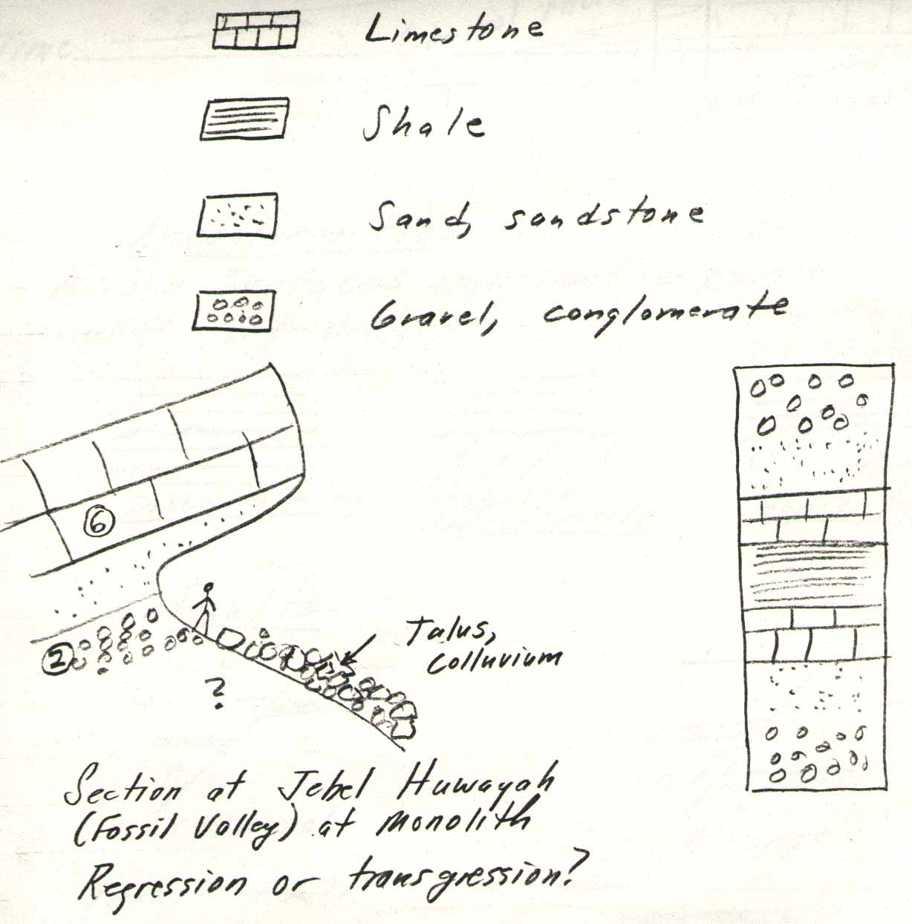

Regression or transgression? Regression

Facies

Sediment (later rock) deposited in a particular sedimentary environment, eg. beach facies, shallow marine facies.

Geological Formations

Generally follow facies boundaries rather than time boundaries.

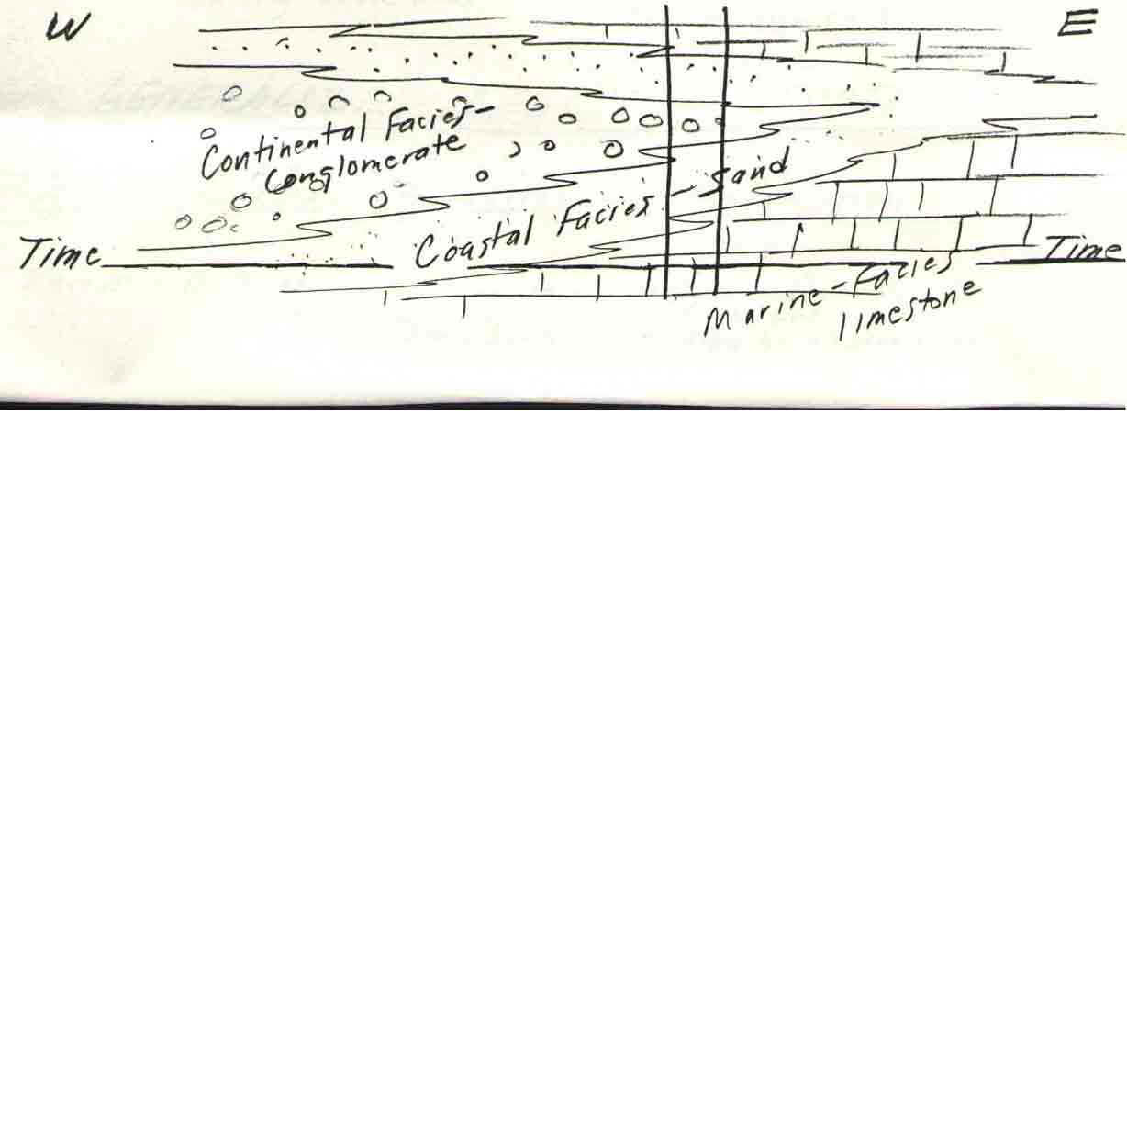

Unconformities

Erosion surfaces represent a period of uplift and erosion.

Erosion Surfaces

Disconformity Angular unconformity Nonconformity

Faults

A fault is a fracture or dislocation in the earth’s crust along which there has been displacement of the rocks on one side relative to those on the other. The movement of the rocks on a fault may have been in any direction, vertical or horizontal or some combination of these.

Hanging-wall
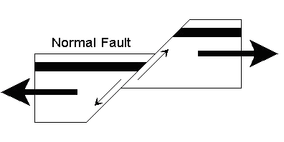
Foot-wall

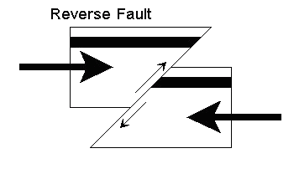

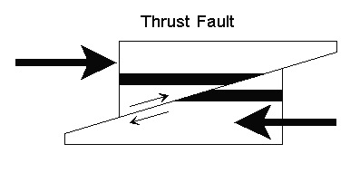

(low angle reverse fault)

Dikes and Sills

Dikes (or Dykes) are igneous intrusions that occur as sheet-like bodies with near-parallel sides and are normally discordant, cutting across the rock, and are usually vertical or nearly so.

Sills are sheets which have been intruded by overcoming a vertical pressure and are roughly horizontal.

Both are always younger than the rocks they cut.

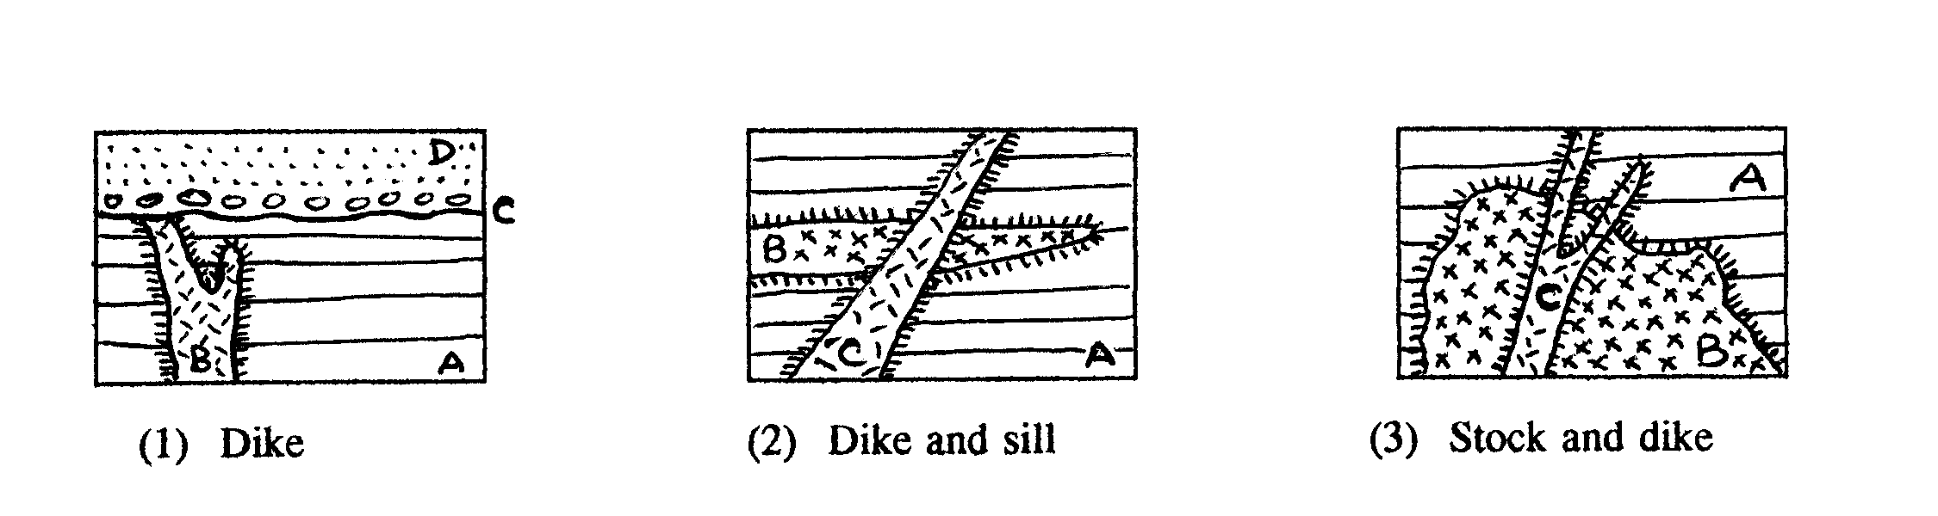

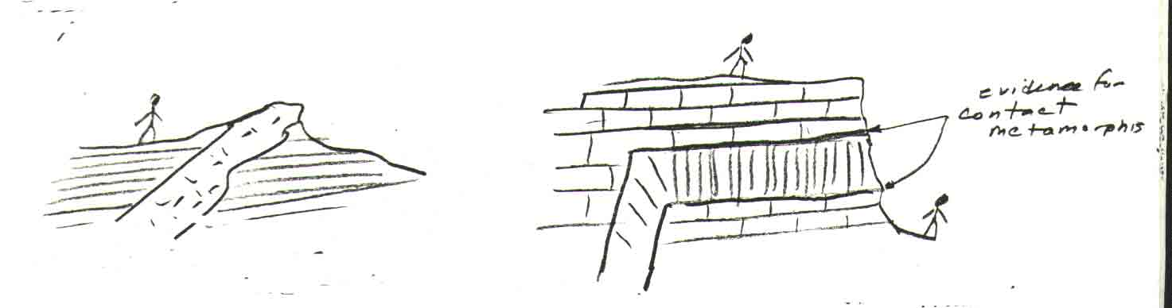

Granite dike cutting shale beds Basalt sill cutting limestone

IV – Generalized Regional Stratigraphy

Age | How old (years B.P.) | Formation | Description | Sample Number
Recent | 0-20,000 | Alluvium, Dune Sand | Deposited in alluvial fans, channels  Deposited as sand dunes | -  //
Tertiary | 40,000,000 | Juweiza  Simsima | Deeper marine facies mudstones, siltstones, marls,clays  Shallow marine facies limestones, fossiliferous limestones, conglomerates (continental) | /  3,6,2
Upper Cretaceous | 70,000,000 | Ophiolites | Peridoties, serpentines, gabbros | 8
Mesozoic | 260-70,000,000 | Hawasina | Limestones, cherts, silicified limestones, silicified shales | 4,7
Triassic | 250,000,000 | Exotic Limestone |  | 5
Mesozoic | 260-70,000,000 | Sumeini Group | Conglomerates, mudstones, shales, cherts | -

V – Sand Dunes

Sand dunes are hills that are formed by wind-blown sand. Once a mound forms, it tends to grow because the friction of the sandy surface slows down the wind, which then cannot carry so much material. The excess is deposited on the dune.

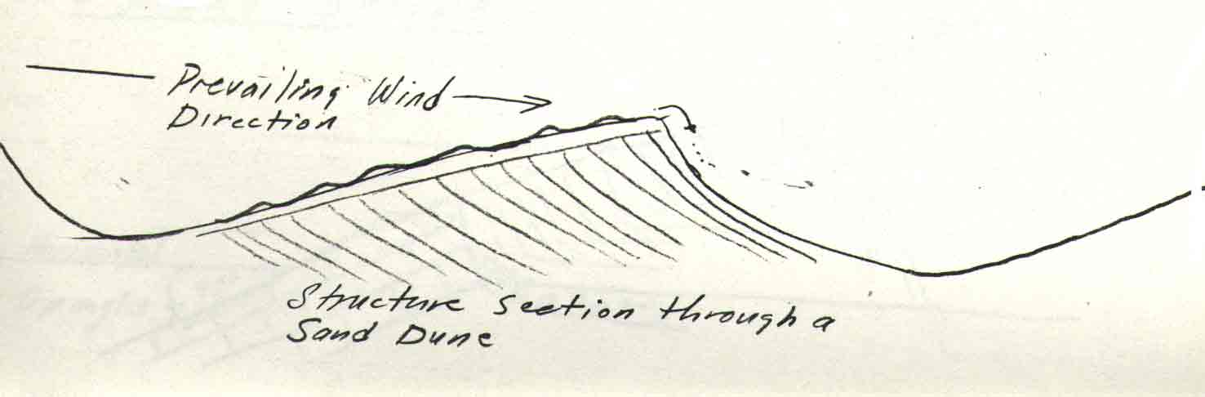

Barchans

Are asymmetrical crescentic dunes formed in sand deserts over solid sand cover.

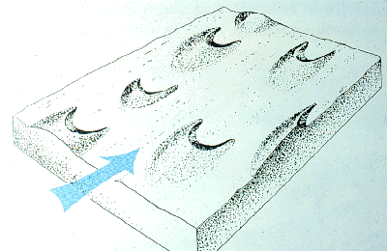

Windward

Long and gentle windward slope 10-15°,
short and steep leeward slope.
Steepness determined by the max. angle of repose of dry sand 32-33°.
Leeward

( Plan view )

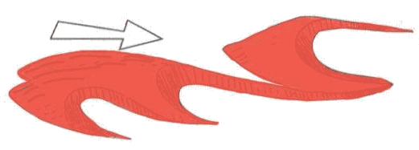

Rows of barchans

Barchans merge forming rows extending perpendicular to the prevailing wind direction.

Transverse dune

Linear dune that moves perpendicular to the wind.

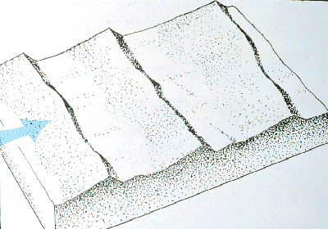

Where did all this sand come from?
The sand comes from the erosion of pre - existing rocks into sand - sized particles. Possibly one major reason why there is so much sand is because during the Ice Ages (which ended about 20,000 years ago) the seabed was about 100 meters lower, exposed high and dry. This may have provided the source for much of the wind - blown sand.

VI – Beach Processes

Erosion: there are many causes of beach erosion. Most of them are natural. These are currents, storms, earthquakes, winds, waves, tides and also the gradual movement of tectonic plates. Some beaches are also destroyed by men when harbours are built. The existence of cliffs on a coastline indicates that erosion is taking its toll on the beach.

Deposition is the geological process whereby material is being added to a landform. It is the process by which wind, water or ice creates a sediment desposit through the laying down of granula material that has been eroded and transported from another geographical location. Deposition occurs when the forces responsible for sediment transportation are no longer sufficient to overcome forces of particle weight and friction that resist motion.

VII – Structural Geology

Dip and Strike

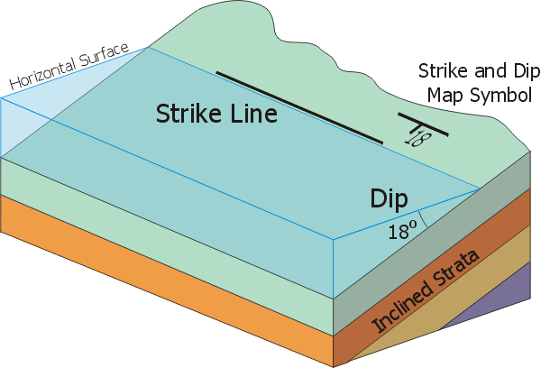

Dip is the angle the bed makes with a horizontal plane.

Dip direction is the compass direction the bed is tilted towards (always 90° to the strike).

Strike is the compass direction of the trend of the outocrop.

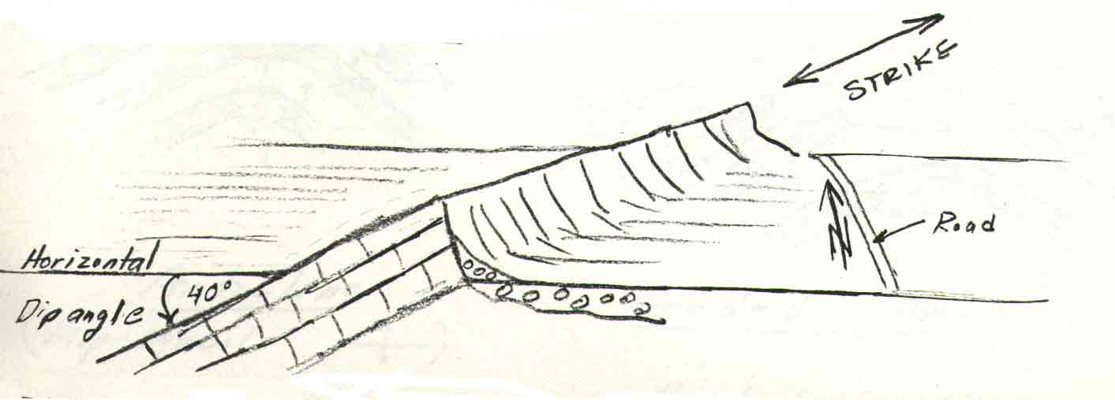

In the above diagram what is the dip, dip direction and strike?

Map symbols

40 Strike NE
Dip 40° NW

Strike______
Dip _______

Srike ______
Dip 0°

Strike ______
- Dip ____ ____

Strike ______
Dip 90°

Anticlines and Synclines

Axis
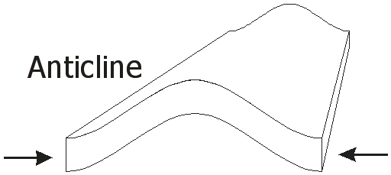

(map symbol: )

Eroded Anticline

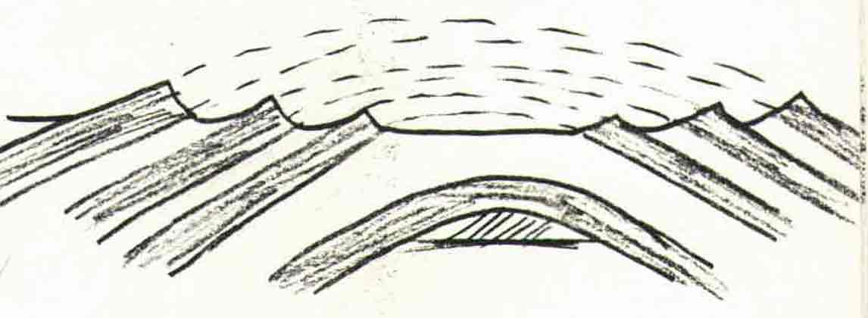

Are beds getting younger or older towards the axis?

Are the beds getting younger or older towards the axis? [Younger]

Are beds getting younger or older towards the axis? Younger

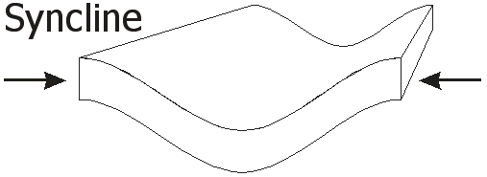

(map symbol: )

Eroded Syncline

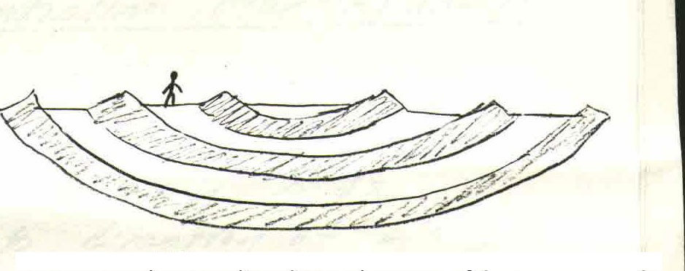

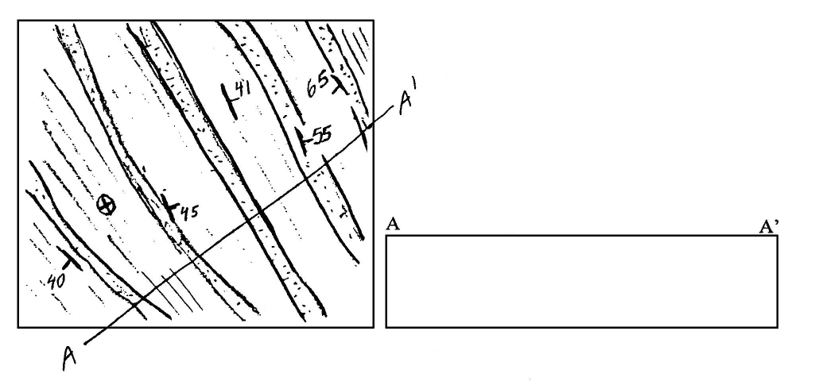
Geological Map Geological Section
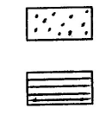

Sandstone

Shale

1 - What is the strike of the beds?

2 - Draw in the axes.

3 - Sketch in structure section along line A

Plunging Folds

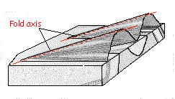

Block Diagram of Anticline Plunging South

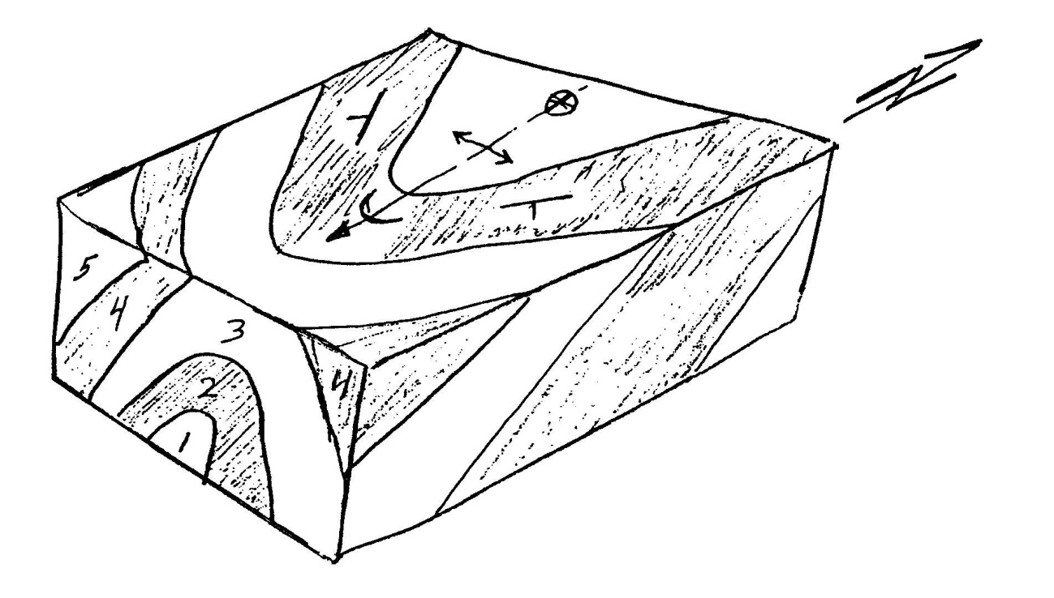
Fill in bed numbers on map and on east face.

Plunging anticlines – on map beds converge in direction of plunge.

Plunging synclines – on map beds converge opposite to direction of plunge.

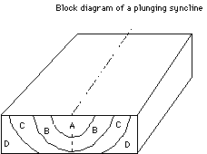N

Fill in map and east face for syncline plunging north

Put in structural geology map symbols on Jebel Huwayah, Jebel Hafit, Jebel Qatar

VIII – Interpreting Geologic History from a Geologic Section

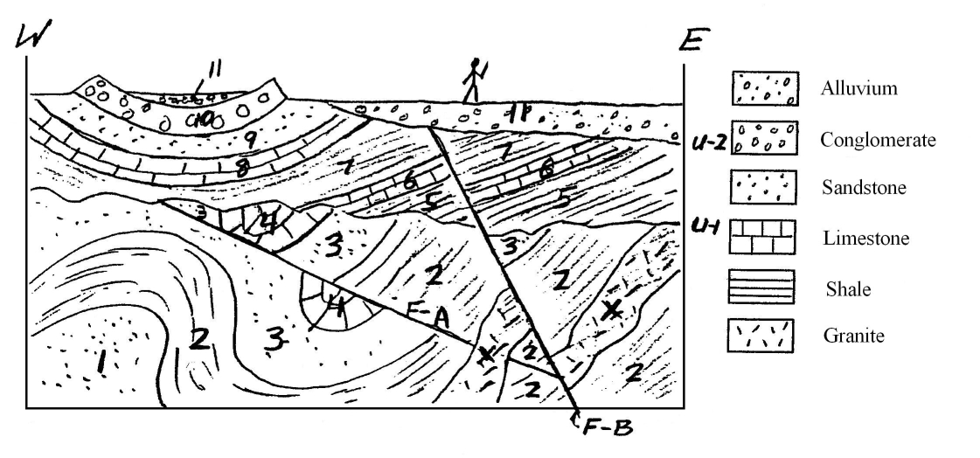

1 - Which is the oldest bed?
2 - Which is the youngest bed?
3 - What is the age of X?
4 - Is X a dike or a sill?
5 - What kind of fold is 8,9,10?
6 - What kind of fold is 1,2,3?
7 - What kind of fault is F-A?
8 - What kind of fault is F-B?
9 - Which is older F-A or F-B?
10 - What is the age of F-A?
11 - What is the age of F-B?
12 - What kind of unconformity is U-2?
13 - What kind of unconformity is U-1?
14 - How many times was the area uplifted out of the sea?
15 - What happened to the sea between 7 and 10?
16 - Where would be the best place to drill for oil?
17 - Describe the geological history of the area based on the section.




